**Votran Title VI Program**

**Update 2019**

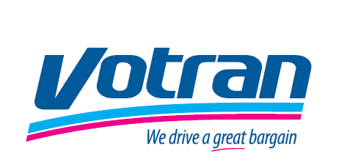

Prepared for Federal Transit Administration

By Votran Staff

(Recipient number 1081)

950 Big Tree Road South Daytona, FL 32119 Prepared: October 2019

TABLE OF CONTENTS

INTRODUCTION 1

SECTION 1.0 General Reporting Requirements 2

1.1 Notice to the Public 2

1.2 Complaint Procedure 4

1.3 Active Lawsuits or Complaints 5

1.4 Public Participation Plan 6

1.5 Limited English Proficiency (LEP) 11

1.6 Minority Representation on Committees and Councils 14

1.7 Monitoring Sub-recipients 14

1.8 Title VI Equity Analysis for facilities 14

1.9 Board Approval of Title VI Documentation 15

SECTION 2.0 Program Specific Requirements 15

2.1 Service Standards 15

2.2 Service Policies 18

2.3 Implementation of Service Changes 18

SECTION 3.0 Demographics, Monitoring and Analysis 19

3.1 Demographic Analysis 19

3.2 Demographic Ridership and Travel Patterns 22

3.3 Monitoring Transit Service 22

3.4 Service Change Policies 26

SECTION 4.0 Conclusion and Assessment of Compliance 28

APPENDIX 1 Complaint Form 29

APPENDIX 2 Demographic Data, Maps and Public Outreach 32

APPENDIX 3 - Public Participation Policy 41

**INTRODUCTION**

This major update has been prepared pursuant to Title VI of the Civil Rights Act of 1964; Federal Transit Administration (FTA) Circular 4702.1 B “Title VI Program Guidelines for Federal Transit Administration Recipients,” (October 1, 2012). Also, this update includes the program elements required for an agency operating 50 or more fixed route vehicles in peak service and are located in urbanized areas of 200,000 or more people. Section 3 addresses the required elements for demographic analysis, monitoring and statements of policies regarding service changes.

Service delivery review and analyses are typically performed as part of the Title VI program and during the major update to the Transit Development Plan. This document is developed every 5 years. During the intervening period surveys are conducted that when route changes are reviewed.

A comprehensive review of service is conducted as part of the Transportation Development Plan, the most recent having been completed October 2016, approved by Volusia County Council on October 20, 2016.

Title VI of the Civil Rights Act

Votran is committed to ensuring that no person shall on the basis of race, color or national origin, sex, age, disability, family or religious status, as provided by Title VI of the Civil Rights Act of 1964, the Civil Rights Restoration Act of 1987, and the Florida Civil Rights Act of 1992 be excluded from participation in, be denied the benefits of, or be otherwise subjected to discrimination or retaliation under any Votran program or activity.

Environmental Justice

Title VI of the 1964 Civil Rights Act and the 1994 U.S. Department of Transportation (DOT) Order on Environmental Justice requires that the transportation planning process seeks to identify the needs of low-income and minority populations. Votran is committed to enhancing public involvement activities to identify and address the needs of minority and low-income populations in making transportation decisions.

**Limited English Proficiency (LEP)**

Public transportation providers receiving federal funding from the DOT have a responsibility, under Title VI of the Civil Rights Act of 1964, to take reasonable steps to ensure Limited English

Proficiency (LEP) persons have meaningful access to benefits, services, information, and other important programs and activities. Persons with LEP include individuals who have a limited ability to read, write, speak, or understand English. Votran is committed to creating a positive environment for persons with LEP and ensuring that they have an opportunity for full participation in public involvement activities.

Special Accommodations

Persons who require special accommodations under the Americans with Disabilities Act (ADA) or persons who require translation service to participate in public meeting activities are requested to notify Votran at least forty-eight hours prior to workshops or meetings. Requests for alternative format materials or translation should be made in advance to accommodate the development and provision of these materials. Votran public meeting notices will include the Votran staff contact phone number and deadline date for requesting special accommodations at workshops or meetings.

**Organization and Service**

The Volusia County Council created Volusia County’s public transportation system, d/b/a Votran, in 1975 as a service of Volusia County Government. Votran provides transportation to urban areas of the county with 27 fixed routes and 2 flex routes. In addition to providing fixed-route service, Votran provides complementary paratransit services as required under the Americans with Disabilities Act (ADA), peak hour connecting bus service to the DeBary SunRail station, and a commuter van pool program. Votran also functions as the Community Transportation Coordinator (CTC), providing services under the Transportation Disadvantaged (TD) program, rural trips, and agency-sponsored trips.

SECTION 1.0 General Reporting Requirements

1.1 Notice to the Public

Votran’s Title VI Notice to The Public is posted inside all Votran buses, Votran’s Main Office, the Transfer Plaza, and on our website www.Votran.org. The Title VI notice can be found on the next page.

**Notice to the Public of Non-Discrimination Rights**

Title VI of the Civil Rights Act of 1964 prohibits discrimination based on race, color, and national origin in programs and activities receiving Federal financial assistance (42 U.S.C. Section 2000d). In addition, Votran also prohibits discrimination based on religion, age, gender, disability, and/or marital status in accordance with section 303 of the Age Discrimination Act of 1975, as amended, 42 U.S.C. § 6102, section 202 of the Americans with Disabilities Act of 1990, 42 U.S.C. § 12132, and Federal transit law at 49 U.S.C. § 5332.

Votran is committed to practicing non-discrimination. If you believe you have been subjected to discrimination you may file a complaint with the Votran Civil Rights Officer at 386-756-7496, or with the Florida Commission on Human Relations at 850-488-7082 or 800-342-8170 (voice messaging), or with the Federal Transit Administration Office of Civil Rights, Attention Title VI Program, East Building, 5th Floor-TCR, 1200 New Jersey Avenue, SE, Washington, DC 20590.

El Título VI de la Ley de Derechos Civiles de 1964 prohíbe la discriminación por motivos de raza, color y origen nacional en los programas y actividades que reciben asistencia financiera federal (42 U.S.C. Sección 2000d). Además, Votran también prohíbe la discriminación por motivos de religión, edad, género, discapacidad o estado civil de conformidad con la sección 303 de la Ley de Discriminación por Edad de 1975, en su forma enmendada, 42 U.S.C. § 6102, sección 202 de la Ley de Americans with Disabilities Act de 1990, 42 U.S.C. § 12132, y la Ley Federal de Tránsito en 49 U.S.C. § 5332.

Votran se compromete a practicar la no discriminación. Si usted cree que ha sido objeto de discriminación, puede presentar una queja ante el Oficial de Derechos Civiles de Votran al 386-756-7496, o ante la Comisión de Relaciones Humanas de Florida al 850-488-7082 o 800-342-8170 (mensaje de voz), o con la Oficina De Tránsito Federal de Administración de Derechos Civiles, Programa de Título de Atención VI, Edificio Este, 5th Piso -TCR, 1200 New Jersey Avenida, SE, Washington, DC 20590.

1.2 Complaint Procedure

A complaint procedure and the complaint form is established as part of the approved Title VI program. The complaint form appears in Appendix 1.

Title VI Complaint Procedure

1. Any person who believes that he or she, or any specific class of persons, has been subjected to discrimination or retaliation prohibited by the Title VI of the Civil Rights Act of 1964, as amended, and related statutes, may file a written complaint. Votran investigates complaints received no more than 180 days after the alleged incident. All written complaints submitted to Votran’s Customer Service Department shall be referred immediately by the Customer Service Manager to the Florida Department of Transportation’s (FDOT) District Five Title VI Coordinator for processing in accordance with approved State procedures.
2. Verbal and non-written complaints received by Votran‘s Customer Service Department shall be resolved informally by the Customer Service Manager. If the issue has not been satisfactorily resolved through informal means, or if at any time the person(s) request(s) to file a formal written complaint, the Civil Rights Officer shall refer the complaint to the FDOT’s District Five Title VI Coordinator for processing in accordance with approved State procedures.
3. The Civil Rights Officer will advise the FDOT’s District Five Title VI Coordinator within five (5) calendar days of receipt of the allegations. The following information will be included in every notification to the FDOT’s District Five Title VI Coordinator:
4. Name, address, and phone number of complaint.
5. Name(s) and address (es) of Respondent.
6. Basis of complaint (i.e., race, color, national origin, sex, age, disability, religion, familial status or retaliation.)
7. Date of alleged discriminatory act(s).
8. Date of complaint received by Votran
9. A statement of the complaint.
10. Other agencies (state, local, or Federal) where the complaint has been filed.
11. An explanation of the actions that Votran has taken or proposed to resolve the allegation(s) raise in the complaint.

1. Within ten (10) calendar days, the Civil Rights Officer will acknowledge receipt of the allegation(s), inform the Complainant of action taken or proposed action to process the allegation(s), and advise the complainant of other avenues of redress available, such as the FDOT’s Equal Opportunity Office (EOO).
2. Within sixty (60) calendar days, the Civil Rights Officer will conduct and complete a review of the verbal or non-written allegation(s) and based on the information obtained, will render a recommendation for action in a report of findings to the General Manager of Votran.
3. Within ninety (90) calendar days of the verbal or non-written allegation(s) receipt, the Civil Rights Officer will notify the Complainant in writing of the final decision reached, including the proposed disposition of the matter. The notification will advise the Complainant of his/her right to file a formal complaint with the FDOT’s EOO, if they are dissatisfied with the final decision rendered by Votran. The Civil Rights Officer will also provide the FDOT’s District Five Title VI Coordinator with a copy of this decision and summary of findings.
4. The Civil Rights Officer will maintain a log of all verbal and non-written complaints received by Votran. The log will include the following information:
5. Name of Complainant.
6. Name of Respondent.
7. Basis of Complaint (i.e., race, color, national origin, sex, age, disability, religion, familial stats or retaliation).
8. Date verbal or non-written complaint was received by Votran.
9. Date Votran notified the FDOT’s District Five Title VI Coordinator of the verbal or non-written complaint.
10. Explanation of the actions Votran has taken or proposed to resolve the issue raised in the complaint.

1.3 Active Lawsuits or Complaints

Votran has no active lawsuits or complaints alleging discrimination on the basis of race, color, or national origin with respect to service or other transit benefits. No such lawsuits or complaints have been filed since the previous Title VI report.

1.4 Public Participation Plan

With its authority and mission to serve Volusia County with a full array of mobility options, Votran maintains a program to proactively inform the public and afford public involvement in the early development and implementation state of Votran services, service changes, fare adjustments, capital investments, and planning activities when appropriate in accordance with federal and state rules and regulations. It is the intent of Votran to ensure its actions are reasonable, non-capricious, and considerate of public comment in its mission to provide mobility services for the welfare and convenience of residents and visitors.

Votran operates programs without regard to race, color, and national origin.

Votran implements its public involvement program by utilizing continuous communications and various outreach techniques appropriate to the proposed action to be taken and the public groups to be affected. In accordance with Votran’s Public Involvement Program, these Administrative Operating Procedures have been developed to ensure proper public input to the development and implementation of Votran mobility services.

Within the last three years, Votran has increased the number of outreach activities. Some of those activities include the launch of two new routes, newspaper ads, a presentation at a Spanish speaking church, Mobility Week, farmers markets, information table at local Libraries, service adjustment public meetings, and onboard surveys. Paratransit applications and user guides in English and Spanish were also distributed at these outreach events. Bilingual staff was also available at these meetings.

There are two types of activities for which procedures are established:

1. Activities that require public involvement based on federal and/or state regulations: and
2. Activities for which Votran desires public involvement as part of its overall strategies to provide market driven transportation services.

Below are specific activities that warrant public involvement for the two types of activities.

**Fare Increases**

Required Activities

Fare increases are increases to the base full adult fare. When the full adult fare is increased, discount fares and fare media may also be increased at the same time. Fare increases are adopted by the Volusia County Council. Once initiated, the General Manager is to conduct the following activities to solicit public input:

1. Prepare notices in the form of press releases and notices on-board buses;
2. Schedule public hearings;
3. Notice public hearings in accordance with notice procedures below;
4. Hold public hearings to gain public input.

Other Activities Related to Fare Increases – Not Required

When deemed appropriate and reasonable, the General Manager may also elect to conduct other activities to solicit public comment, including but not limited to:

1. Hold public workshops in communities affected by the fare increases.
2. Make presentations to local jurisdictions;
3. Make presentations to business and community groups; and
4. Publicize the fare increase via promotions on radio, television, and newspapers.

Service Reductions

Service Reductions occur when Votran does the following to an individual route or to set of routes:

1. Reduce the span of service hours (hours in a day when service operates);
2. Reduce the days in which service operates;
3. Reduce the frequency of service;
4. Elimination of a route, unless the route is a planned service development or experimental services that have been in existence less than two years.

Require Activities

Public involvement is required if any of the above activities impact more than 10% of an individual route total service hours or 10% of an individual route’s current ridership. When the General Manager deems that one or both criteria have been met, the following activities will occur.

* + - 1. Make presentation to the Volusia County Council;
      2. Schedule a public hearing;
      3. Publish public hearing in accordance with notice procedures listed below; and
      4. Hold public hearing to gain public input.

Other Activities Related to Service Reductions – Not Required

1. When deemed appropriate and reasonable, the General Manager may also elect to conduct other activities to solicit public comment, including but not limited to:
2. Hold public workshops in communities affected by the service reductions;
3. Make presentations to local jurisdictions;
4. Make presentations to business and community groups; and
5. Publicize service alternatives via promotions on radio, television and in newspapers.

Capital Investments

Capital Improvement Projects (CIP), shall be programmed in the annual update of Votran’s Transportation Development Plan and the River to Sea Transportation Planning Organization (R2CTPO), Transportation Improvement Program. R2CTPO provides a process for early consultation and public involvement to citizens, affected public agencies, and representatives of transportation agencies, private providers of transportation, other interested parties, and local jurisdiction concerns. The TPO presents all key issues to its technical committees, and the Citizens Advisory Committee, which is comprised of private citizens in the urban area. Public hearings are also held on the Long Range Transportation *Plan* and the Transportation Improvement Program prior to adoption by the R2CTPO.

The public involvement process will be as follows:

1. Once annually, Votran will develop a Capital Improvement Program (CIP), proposed to be funded with federal funding.
2. The CIP shall then be incorporated into the Transportation Improvement Program (TIP), and submitted to the TPO for Consideration.
3. The TPO then completes a public involvement process that includes consulting with technical and citizens committees, holding a public hearing, and final adoption by the River to Sea Transportation Planning Organization (R2CTPO).

Public comments received regarding the CIP or TIP will be considered by Votran throughout the adoption process and incorporated into final programs.

Public Notice

When formal public notice is warranted for public hearings, Votran shall publish notice at least twenty-one (21), days prior to proposed action(s). The notice shall include:

1. Proposed of public hearing;
2. The date, time, and location of the public hearing;
3. Address and business hours whereby information regarding the action can be available for public review;
4. Contact address and period of time in which written public comment will be received;
5. Contact telephone number for public to gain additional information.
6. Any person who believes she or he has been subjected to discrimination may file a complaint with the Votran Civil Rights Officer at 386-756-7496, or with the Florida Commission on Human Relations at 850-488-7082 or 800-342-8170 (voice messaging), or with the Federal Transit Administration Office of Civil Rights, Attention Title VI Program, East Building, 5th Floor-TCR, 1200 New Jersey Avenue, SE, Washington, DC 20590.
7. Large prints of Votran maps are available as well as Spanish speaking staff.

After the public hearing and at the conclusion of public comment period, the General Manager is charged with summarizing and packaging all public comments for presentation to the Volusia County Council prior to the time action is taken.

Public hearings conducted by the Volusia County Council shall be at regularly scheduled monthly meetings that are published each year for the following year. Public hearings by staff may be conducted at any time on federal or state requirements or based on the impacts to a particular community or customer base. Notice provisions for public hearings shall be the same as those indicated above.

All public comments received through any of the means listed above will be summarized and presented to the Volusia County Council prior to adoption or implementation of the action taken.

Public Outreach Activities

Public outreach is actively pursued by Votran and may take various forms tailored to the specific activity involved. Public outreach activities are designed to increase public awareness of Votran, survey public attitudes regarding transit improvements, and to gain public consensus and support for the importance of public transportation to the quality of life in the region. Votran will seek to maintain a comprehensive and continuous public involvement program to include such efforts as:

1. Development and update of the Transportation Development Plan and Transportation Disadvantaged Service Plan
2. River to Sea Transportation Planning Organization (R2CTPO), Coordination – includes participation in the Technical Committee, Bicycle/Pedestrian Advisory Committee, Board meetings, and presentations when appropriate to the Citizens Advisory Committee.
3. Transportation Improvement Program (TIP) – annual submission to the R2CTPO.
4. Unified Planning Work Program (UPWP) – annual submission of proposed planning projects to the funding in the UPWP.
5. Long Range Transportation Plan – participation and input into development of local jurisdiction transportation system.
6. Votran Customer Service
7. Telephone system that consists of Service Representative Response that enables callers to obtain information regarding Votran services and leave voice messages at the administrative office for further follow up.
8. Internet E-mail with response from Votran staff.
9. Web site <http://votran.org/>
10. Web comment form http://www.votran.org/contact-us/
11. Speakers’ Bureau – includes presentations by Votran staff to community groups, business organizations, elected officials, and neighborhood/community associations.
12. Information and Awareness Program – Includes promotions presenting the Votran image in the community to riding and non-riding customers.

1.5 Limited English Proficiency (LEP)

Votran provides information to LEP Persons in a variety of ways.

1. All Votran printed schedules/user guides, etc. are printed in English and Spanish.
2. Onboard Surveys are printed in both English and Spanish.
3. A Spanish Language employee works for the Volusia County Community Information Office.
4. Numerous Votran employees are bi-lingual and available to translate for riders which are LEP persons.

Votran has steps to provide language assistance for LEP persons seeking meaningful access to transit services as required by Executive Order 13166. A Limited English Proficiency person is one who does not speak English as their primary language and who has a limited ability to read, speak, write, or understand English.

This chapter details the methods that Votran uses for persons who may need language assistance and information for future plan updates.

In developing the plan while determining the Votran’s extent of obligation to provide LEP services, Votran undertook a U.S. Department of Transportation four factor LEP analysis which considers the following: 1) The number or proportion of LEP persons eligible in the Votran service area who may be served or likely to encounter an Votran program, activity, or service; 2) the frequency with which LEP individuals come in contact with an Votran services; 3) the nature and importance of the program, activity or service provided by the Votran to the LEP population; and 4) the resources available to the Votran and overall costs to provide LEP assistance. A brief description of these considerations is provided in the following section.

Four Factor Analyses

The Safe Harbor provision of FTA Circular 4702.1B stipulates that, “if a recipient provides written translation of vital documents for each eligible LEP language group that constitutes five percent or 1,000 persons, whichever is less, of the total population of persons eligible to be served or likely to be affected or encountered, such action will be considered strong evidence of compliance with the recipient’s written translation obligations.” Votran has identified LEP populations of 1,000 or more individuals who speak English “less than very well” and for whom notice of language assistance and written translation of vital documents is required: Spanish

According to USDOT guidance, the federally-funded recipient’s obligation to accommodate LEP populations is determined by balancing four factors:

**Factor 1:** the number or proportion of LEP persons eligible to be served, or likely to be encountered, by a program, activity, or service.

**Factor 2:** the frequency with which LEP individuals come in contact with the program, activity, or service.

**Factor 3**: the nature and importance of the program, activity, or service to people’s lives.

**Factor 4:** the resources available to the recipient.

**1. The number or proportion of LEP persons eligible in the Votran service area who may be served or likely to encounter a Votran program, activity, or service.**

*“The greater the number or proportion of LEP individuals from a particular language group served or encountered in the eligible service population, the more likely language services are needed…” (DOT LEP Guidance Section V (1)).*

**AMERICAN COMMUNITY SURVEY DATA**

For Factor One, Votran analyzed census data from the American Community Survey 2011-2015 5-year sample1 to determine the number or proportion of LEP persons eligible to be served or likely to be encountered by a program, activity, or service provided by Votran. ACS census data estimate that of the total population in the Votran service area aged five years and over who speaks a language other than English, 20,815 individuals speak English less than very well. This number represents Votran’s LEP population and is 4.3 percent of the total Votran service area population of 479,923.

Source: <https://factfinder.census.gov/faces/nav/jsf/pages/community_facts.xhtml?src=bkmk>

The most prevalent non-English language spoken in the Votran service area is Spanish (14,882 LEP persons), and these LEP speakers account for 3.1 percent of the total population within this service area. This language group represents Votran’s Safe Harbor languages **(Table 3).**

**Table 3: Volusia County LEP Estimates for the Population 5 Years and Over**

|  |  |  |  |  |
| --- | --- | --- | --- | --- |
| **Volusia County LEP Estimates for the Population 5 Years and Over** | | **ACS LEP Population (speaks English less than very well)** | **% of Total Population** | **% of Total LEP Population** |
| **Total Population ACS 2011-2015** | *479,923* | *20,815* | *4.34%* |  |
|  | |  |  |  |
| **Spanish or Spanish Creole** | | 14,882 | 3.10% | 71.5% |
| Chinese | | 839 | 0.16% | 4.03% |
| French Creole, Patois, Cajun | | 495 | 0.10% | 2.38% |
| Italian | | 451 | 0.09% | 2.17% |
| Arabic | | 389 | 0.08% | 1.87% |
| German | | 357 | 0.07% | 1.72% |
| Tagalog | | 297 | 0.06% | 1.43% |
| Vietnamese | | 280 | 0.06% | 1.35% |
| Portuguese | | 280 | 0.06% | 1.35% |
| Other Indic Languages | | 256 | 0.05% | 1.23% |
| Hindi | | 217 | 0.05% | 1.04% |
| Russian | | 181 | 0.04% | 0.87% |
| Gujarati | | 170 | 0.04% | 0.82% |
| Hungarian | | 169 | 0.04% | 0.81% |
| Japanese | | 144 | 0.03% | 0.68% |
| African Languages | | 141 | 0.03% | 0.68% |
| Polish | | 141 | 0.03% | 0.68% |
| Thai | | 130 | 0.03% | 0.62% |
| Other Indo-European Languages | | 113 | 0.02% | 0.54% |
| Scandinavian Languages | | 101 | 0.02% | 0.49% |
| Korean | | 99 | 0.02% | 0.48% |
| Other Slavic Languages | | 95 | 0.02% | 0.46% |
| Urdu | | 89 | 0.02% | 0.43% |
| Greek | | 89 | 0.02% | 0.43% |
| Other Asian Languages | | 80 | 0.02% | 0.37% |
| Mon-Khmer, Cambodian | | 75 | 0.02% | 0.35% |
| Hmong | | 70 | 0.01% | 0.34% |
| Other West Germanic Languages | | 50 | 0.01% | 0.24% |
| Hebrew | | 33 | 0.01% | 0.16% |
| Persian | | 27 | 0.01% | 0.13% |
| Serbo-Croatian | | 27 | 0.01% | 0.13% |
| Other Pacific Island Languages | | 26 | 0.01% | 0.12% |
| Laotian | | 15 | 0.00% | 0.07% |
| Other Native North American | | 7 | 0.00% | 0.03% |
| Other and Unspecified Languages | | 0 | 0.00% | 0.00% |
| Armenian | | 0 | 0.00% | 0.00% |
| Yiddish | | 0 | 0.00% | 0.00% |
| Navajo | | 0 | 0.00% | 0.00% |
| **Total LEP** | | **20,815** | **4.34%** | **100.00%** |

Using ACS data, Votran’s LEP language group (Spanish) was identified by their estimated populations within each of Volusia County’s cities (**Table 4**). This information will assist Votran in identifying concentrations of specific language groups within its service area and providing appropriate language assistance for public hearings, meetings, written materials, and other outreach efforts.

**Table 4: Volusia County LEP Population by Census County Division (CCD)**

|  |  |  |
| --- | --- | --- |
| **Census County Division** | **Spanish** | **% LEP Population** |
|  |  |  |
| Deltona CCD | 7,529 | 50.59 |
| Deland CCD | 2,160 | 14.51 |
| DeBary-Orange City CCD | 1,454 | 9.77 |
| Pierson-Seville CCD | 1,035 | 6.96 |
| Ormond Beach CCD | 973 | 6.54 |
| Port Orange CCD | 695 | 4.67 |
| Daytona Beach CCD | 470 | 3.16 |
| New Smyrna Beach CCD | 229 | 1.54 |
| Central Volusia CCD | 211 | 1.42 |
| North Peninsula CCD | 72 | 0.48 |
| South Peninsula CCD | 54 | 0.36 |
|  |  |  |
| **Total Volusia County by Incorporated Cities** | **14,882** | **100.00** |

**GIS ANALYSIS OF THE AMERICAN COMMUNITY SURVEY**

All data sources used to determine the number or proportion of LEP persons eligible to be served, or likely to be encountered by a program, activity, or service provided by Votran confirm that Spanish is the primary LEP language group in Volusia County, representing 3.1 percent of its total population of 479,923 and 71.5 percent of its total LEP population of 20,815.

The City of Deltona has the highest number of Spanish LEP individuals, with Deland, Debary-Orange City, and Pierson-Seville ranking 2nd, 3rd, and 4th respectively.

To provide a geographic picture of where concentrations of LEP individuals live within Votran’s service area, LEP populations were identified by census tract and are represented in the following series of maps. Figure 2 identifies the total LEP population concentration by census tract as a percentage of Votran’s total population, and Figures 3-6 identify each of the four LEP language groups individually by census tract as a percentage of Volusia County’s total population.

**2. The frequency with which LEP individuals come in contact with a Votran program, activity, or service**

Votran staff plan and conduct outreach activities to LEP populations on an annual basis.

Votran recognizes a large concentration of LEP individuals who speak Spanish in areas of Volusia County namely Seville, Pierson, and within the City of Deltona.

Votran staff plan and conduct outreach activities on an annual basis to LEP persons in the areas identified as areas with concentrations of LEP individuals. These activities include providing information about Votran services and employment opportunities and are provided to each area at least twice a year for a total of 8 outreach activities in a calendar year.

Votran’s Human Resources Department participates in job fairs and outreach to LEP community members for employment opportunities as well and to provide educational information on Votran services. Outreach to high Spanish population areas includes HR staff and a bilingual management team member.

Votran receives contact on a daily basis from LEP Spanish speaking passengers seeking information. A bilingual Spanish speaking team member is assigned to handle this interaction. This interaction does include employment opportunities, job interviews, and Votran transit service programs. Votran receives approximately two calls a week from Spanish speaking passengers totaling an average of 100 calls a year. Votran’s HR staff utilities a Spanish speaking management team member for 85% of the job interviews conducted.

**3. The importance of the program, activity, and services to LEP persons**

There is no large geographic concentration of any one type of LEP individuals in the Votran service area. The overwhelming majority of the non-English speaking persons are Spanish.

Therefore, there is a lack of social, service, professional and leadership organizations within the Votran service area that focuses on outreach or membership of LEP individuals. System maps have Spanish language information to assist the community to access services. Whenever there are customer service activities or outreach in the West Volusia area where Spanish speaking customers may be encountered, there is always a Spanish speaking staff member assigned.

The public involvement activities during 2016 included onboard personal interviews conducted in Spanish. Members of the Spanish speaking community with business organizations and community groups were invited to workshops to discuss transit issues to be included in the TDP.

4. The resources available to Votran and overall costs

Votran assessed its available resources that could be used for providing LEP assistance. This included identifying how much a professional interpreter and translation service would cost on as needed basis, which documents would be the most valuable to be translated if and when the populations supports, taking an inventory of available organizations that the Votran could partner with for outreach and translation efforts, and what level of staff training is needed.

After analyzing the four factors, the Votran developed the approach in the following section for assisting persons of limited English proficiency.

Methods for assisting LEP persons

1. Bus schedules: The primary publication in use for transmitting service description is the published schedule. It contains service description in Spanish specifically on the subjects of: Welcome message containing system overview; fare information and where to buy passes; travel tips on how to ride the bus. This document is on the web.
2. Persons with disabilities: Votran’s Para transit service is described in a guide book which has been approved by the Transportation Disadvantaged Local Coordinating Board. It is also published in Spanish. A spoken version can be distributed on tape. All of these formats are on the web for download.
3. Language assistance: The online translation applications are used to provide written assistance whenever requested. Customer service staff will identify circumstances requiring an interpreter. The nature of the language assistance varies and each special circumstance is reviewed by the Customer Service manager or an Operations Supervisor.
4. Public Notices: As service change may affect riders in the West Volusia area with higher representation of minorities, the notice is published in Spanish.
5. Special language needs: Votran’s Customer Service Manager has service arrangements with travel training providers in order to assist any person who needs interpretation or language assistance.

1.6 Minority Representation on Committees and Councils

As noted in the FTA circular C 4702.1B "Recipients that have transit-related, non-elected planning boards, advisory councils or committees, or similar bodies, the membership of which is selected by the recipient, must provide a table depicting the membership of those committees broken down by race, and a description of efforts made to encourage the participation of minorities on such committees."

As a service of the Volusia County Government, Votran’s decision-making body is the Volusia County Council. Members of the Volusia County Council are elected representatives. Votran does not have a board, an advisory council or committee, the membership of which is selected by Votran. This requirement does not apply.

1.7 Monitoring Sub-recipients

Votran is the FTA designated recipient but does not have any arrangements with sub recipients. All contracted service is monitored in compliance with FTA requirements.

1.8 Title VI Equity Analysis for facilities

The Votran Westside Facility was acquired under long term lease as a maintenance facility.

The Westside Maintenance Facility is a project intended to minimize unproductive vehicle hours by consolidating the storage and maintenance of the fleet used for Votran’s Westside operation. Over many years options for site development have been under review. A site was selected at 924 East Rhode Island in Orange City and a 30-year lease was executed by County Council.

This site existed as an industrial property with office space, shop space, and an equipment yard with fueling station. Old fuel tanks were removed and new fuel tanks have been installed that meet current EPA standards.

The facility was acquired by Volusia County with Section 5307 funding. All contracts and alterations were under the management of the Volusia County Project Manager, with oversight responsibilities that ensured the accessibility requirements have been satisfied. The report documenting concurrency exception completed August 2013 included an environmental justice review. It was submitted for the planning stage of the Section 5307 grant supporting this project and FTA approval allowed completion of the project.

1.9 Board Approval of Title VI Documentation

The Votran Title VI program update is published on the Votran’s web site www.votran.org and is scheduled for the December 2019 agenda of the Volusia County Council is pending the satisfactory review of this document by FTA. Documentation of approval will be appended to this document.

SECTION 2.0 Program Specific Requirements

VOTRAN provides this section according to the FTA guidance for agencies that operate more than 50 fixed-route vehicles in peak operation. The prior update was conducted based upon the service threshold for operators of more than 50 vehicles in peak service.

As the designated recipient for an urbanized area exceeding 200,000 population, review and analyses are typically performed as part of the Title VI program and during the major update to the Transit Development Plan. A comprehensive review of service is conducted as part of the Transportation Development Plan, the most recent having been completed October 2016 and published on our web site. This document is developed every 5 years. The most recent assessment of service was conducted under contract in 2016. No disparities were identified.

Votran has established a service review process in support of the Volusia County budget system. The Executive Committee is challenged to 1) review and evaluate service performance and efficiency, 2) review and incorporate customer requests and comments into service changes, 3) coordinate service change work tasks throughout the organization to ensure proper and timely implementation, 4) assist in prioritizing short service changes, and 5) review equity and accessibility of service.

The administration of the service change process is an organization wide responsibility. Coordination of public involvement is provided by Senior Planner. Final approval of service delivery decisions rests with the General Manager of Votran.

2.1 Service Standards

Votran service standards and policies are outlined below.

**Vehicle Load:** Votran addresses vehicle overloads by increasing frequency or placing higher capacity vehicles on overloaded routes. Seasonal or short term unexpected vehicle overloads are handled through the use of “tripper” buses until a system service change can be prepared to increase the scheduled frequency on the targeted route. Votran has a service standard specifying load factors shall not exceed 150% of vehicle capacity in peak period.

**Headways:**   Votran currently operates 27 fixed routes, 2 flex routes, and paratransit door-to-door service for persons with disabilities and those who are unable to use regular fixed routes. The majority of the routes operate Monday through Saturday. Service spans from approximately 6 a.m. to 7 p.m., with an average of 60 minute headways. There are 8 routes (Routes 3, 4, 7, 10, 11, 15, 20, and 60) that have 30 minute headways during the daytime service, serving the core area of Daytona Beach and parts of West Volusia County.

Some routes begin earlier and/or operate later than others. On weekdays and Saturdays, service is provided between 6:00 a.m. and 7:00 p.m. On Sundays and holidays, service is provided between 7:00 a.m. and 7:00 p.m in the core Daytona Beach area only. More detailed service description is in the Table 2.0.

Votran must balance the service provided with available funding. The current configuration of service best meets the demand of when and where service is needed. The unique limitations of each route's service area compose the gaps in the overall service network. Votran will address frequency improvement as funding becomes available.

**On-time Performance:** Votran monitors on-time performance and records the number of early, on-time, and late arrivals at major time points. The on-time service standard is 90%. Fixed route: “early” as any time point reached more than 59 seconds in advance of the scheduled arrival time; a departure that is 5 minutes or later is recorded as “late”. Paratransit service: any arrival time after the appointment time is recorded as late. System performance is tabulated on a monthly basis and reviewed by management team members.

In addition Votran’s Customer Service Department tracks all complaints. The process includes logging the complaint on a Service Report and assigning a tracking number. The reports are entered into a tracking system and are reviewed regularly by the Complaint Review Committee, which determines the appropriate corrective action.

**Service Availability**: Under the American with Disabilities Act of 1990, transit agencies are required to provide access to services via accessible fixed route buses or complementary Paratransit service. For disabled passengers unable to functionally access a fixed route stop, Paratransit services are offered for the ¾ mile legal limits. All fixed route vehicles are equipped for full ADA accessibility. Votran’s entire fixed route bus fleet is bicycle accessible. Individuals who cannot access a bus stop within a comfortable walking distance and/or those who prefer to combine the use of their bicycle with the convenience of riding a bus, can now access any fixed route bus in the system. Votran’s program further extends customer access to Volusia County’s fixed route network throughout the service areas. This allows for more transit riders to utilize their bike to get to and from their bus stop.

Votran determines service availability based on financial resources, public input, performance of existing routes, transit orientation index (population and employment density, income, age, and zero-car households), safety guidelines, and development patterns. For passengers with disability who are unable to functionally access a fixed route stop, Paratransit services are offered for the ¾ mile legal limits. All fixed route vehicles are equipped for full ADA accessibility.

2.2 Service Policies

Votran ensures the equitable distribution of capital improvements is guided by the following policies.

**Distribution of Transit Amenities:** Votran participated in the 2013 update to the FDOT document on the subject entitled “Accessing Transit”. The Votran Transit Development Design Guidelines (TDDG) were published in 2016 to provide the transit design standards and processes used to construct the transit infrastructure needed in the built environment. This guide has been developed in collaboration with the TPO, and public involvement committees, to be used in coordination with the River to Sea Transportation Planning Organization’s Transportation Impact Analysis (TIA) guidelines process with emphasis given to the transit corridors within the existing and planned Votran service area.

Votran works with a contractor to produce engineering documents for bus stop accessibility improvements in the unincorporated part of Volusia County. The project includes the construction of concrete bus stop pads meeting ADA accessibility guidelines. Research findings for the 2016 major update of the Transit Development Plan identified the need for continued enhancements in transit amenities throughout the service area including shelters, park and ride facilities, and Superstops/Transit Centers. This policy does not apply to transit providers that do not have decision-making authority over the positioning of transit amenities. Votran, a service of Volusia County Government, does not have jurisdiction to establish policy for positioning transit amenities within cities.

**Vehicle Assignment:** Buses are assigned to all routes for each system service change. Some buses are assigned to specific runs based on load factors (larger buses on more heavily used routes, small buses on less frequently used routes), road factors, and public concern. Buses are assigned to routes based on daily mileage. This technique ensures Votran that all vehicles in the fleet meet the mileage replacement criteria.

2.3 Implementation of Service Changes

Votran continues to monitor service delivery on a monthly basis. Votran continues to research methods to increase the efficiency and effectiveness of all routes.

Internal reviews have been performed annually as the economy continues to pose challenges for continuation of service. Throughout the year the Volusia County Council brings each of their departments to a public meeting to review their levels of service.

Votran has undertaken service reviews in support of the following changes:

FY 14 Fare Increase

The continuing limitations of the economic impact to public services led the Volusia County Council to implement a fare increase from a regular adult fare of $1.25 to $1.75. The fare equity analysis was provided to the FTA Office of Civil Rights in November 2013. The fare increase was phased in over a two year period beginning February 2014 and ending in February 2015.

FY 14 Commuter Bus Connections to SunRail Debary Station

FDOT and the Federal Transit Administration signed the full funding grant agreement marking the official approval for implementing SunRail revenue service, with the successful start date of May 2014. Trains operate on week days every half-hour during peak hours and every one to two hours during off-peak times. Votran worked closely with the SunRail Technical Advisory Committee to develop the connecting bus routes that serve the SunRail station located in the City of DeBary. Funding for Votran service is 100% covered by the FTA and FDOT for the first seven years of operation. FDOT, Votran and LYNX completed the SunRail Fare Policy and participated in the FTA fare and service equity analysis. Votran staff continues to work closely with FDOT to review funding and route plans for feeder bus service connecting passengers to SunRail.

SECTION 3.0 Demographics, Monitoring and Analysis

This section presents tables and graphs describing the community and the measures associated with the service standards in Section 2.1 and the service policies in Section 2.2.

**3.1 Demographic Analysis**

The population profile for Volusia County was presented in a table compiled for the Votran TDP adopted October 2016. The distribution of population throughout the county consisting of approximately 1,200 square miles is further described in maps provided in Appendix 2.



The profile of each route was determined by an analysis of the census blocks within 1/4 of a mile of each route. The minority routes, Routes 5, 6, 10, 11, 15, and 19, in the urbanized area on the east side of the county serve the greater Daytona Beach area. The minority routes, Routes 21, 22, 23 and 24, serve the communities in the west side of the county including the largest city, Deltona. The minority Route 60 forms a connection between the Daytona Beach area and the DeLand area on the west side of the county.

|  |  |  |  |
| --- | --- | --- | --- |
| **Route** | **Population (within 1/4 mi)** | **Minority** | **Designation** |
| 1 A1a North | 10,464 | 14.9% | Non-Minority |
| 3 North Ridgewood | 7,959 | 29.6% | Non-Minority |
| 4 South Ridgewood | 11,531 | 28.9% | Non-Minority |
| 5 Center St | 9,767 | 36.3% | Minority |
| 6 North Nova | 18,429 | 46.6% | Minority |
| 7 South Nova | 17,080 | 28.0% | Non-Minority |
| 8 Halifax | 6,756 | 19.8% | Non-Minority |
| 10 Medical Center | 7,022 | 78.7% | Minority |
| 11 Mason Ave | 9,079 | 67.3% | Minority |
| 12 Clyde Morris | 15,268 | 23.8% | Non-Minority |
| 15 Orange Ave | 3,497 | 79.9% | Minority |
| 17a South Atlantic | 8,721 | 14.9% | Non-Minority |
| 18 Intl Speedway | 6,765 | 56.6% | Minority |
| 19 Granada | 10,573 | 18.5% | Non-Minority |
| 20 Deland-Orange City | 10,299 | 32.1% | Minority |
| 21 Deltona | 14,600 | 42.9% | Minority |
| 22 Deltona | 14,937 | 44.3% | Minority |
| 23 Orange City | 7,321 | 36.8% | Minority |
| 24 Pierson - Seville | 2,602 | 34.2% | Minority |
| 25 Howland Blvd | 2,677 | 43.0% | Minority |
| 31 Us 17-92 | 9,631 | 27.6% | Non-Minority |
| 32 Deltona | 4,459 | 28.8% | Non-Minority |
| 33 Dupont Lakes | 6,299 | 33.8% | Minority |
| 40 Port Orange | 6,223 | 14.0% | Non-Minority |
| 41 Edgewater | 5,207 | 11.8% | Non-Minority |
| 44 Nsb To Walmart | 2,289 | 26.8% | Non-Minority |
| 60 East West Connector | 5,701 | 59.4% | Minority |

3.2 Demographic Ridership and Travel Patterns

As part of the TDP public involvement process, an on-board survey was conducted in May/June 2016 to collect socio-demographic information and travel behavior of the existing Votran bus passengers. On-board surveys are an important service assessment tool employed by public transportation agencies as a way to assess how efficiently Votran supplies fixed-route transit service, and how effective those services meet the needs of the area. Feedback from the on-board survey efforts will assist Votran in planning for immediate service improvements and in determining future transit needs in Volusia County. The results from the survey will provide Votran with insight on the demographic make-up and travel characteristics of its existing customer base. In addition, the results from this on-board survey were compared to the results of Votran’s on-board surveys previously completed in 2006 and 2011 when the same questions were included on the different surveys to determine the historical trends for passenger demographics and travel characteristics.

**Survey Approach**

An on-board survey instrument was prepared and administered to bus riders. The survey was translated into Spanish to assist those who were not able to complete the English version. The on-board survey was conducted with the use of portable electronic tablets by a team of trained survey personnel. A total of 1,794 Votran customers participated in completing the on-board survey in the spring of 2016.

Further demographic data, maps and a description of the extensive public outreach conducted in 2016 is provided in Appendix 2.

3.3 Monitoring Transit Service

The following section describes the analysis of service standards measures.

**Vehicle Load**

Votran has established a vehicle load standard of 150% during peak periods, meaning all seats are filled and there are approximately 16 standees, relative to the vehicle’s seating capacity of 31 on the majority of Votran’s fixed-route buses.

Using a random sample of Votran vehicle loads per trip (March 2016 and September 2016), the vehicle loads by route and day were reviewed. March was included in the sample based on the month having some of the highest ridership in order to review the vehicle loads at the system’s peak. September was included as a sample since Votran operates its modified Sunday service during this month in observance of the Labor Day holiday. For each month the data was reviewed by route, weekday, Saturday, and Sunday. The months were then combined for an additional review of the two time periods. Time periods that were over the 150 percent threshold were considered above the daily standard load.

Based on the analysis, the combined results by weekday, Saturday, and Sunday indicate that the overall vehicle loads do not exceed passenger seating capacity. During the month of March Routes 12, 20, and 60 had a couple trips that exceeded capacity, specifically Route 12 on Thursday at 1 P.M. and 2 P.M., Route 20 on Tuesday at 6 P.M., and Route 60 on Tuesday at 6 P.M. and 7 P.M. The trips that exceeded capacity occurred on March 3rd and 8th.

For the month of September Routes 1, 4, 5, 6, 10, 17, 19, and 60 also had an occurrence where specific trips exceeded the 150% vehicle load standard. However, it is important to note that generally for each of these routes, the vehicle operated over the standard vehicle load for only one day out of the month demonstrating that Votran was experience higher than average ridership along that route for that particular day. In addition, the trips that exceeded capacity occurred mainly on Thursday and Friday and on the east side of the county. The time periods that were noted included the afternoon off peak hours of 1 PM to 3 PM and the evening hours of 7 PM to 11 PM. In addition, the analysis indicated that trips occurred the beginning of the month consistent with the Labor Day holiday and the middle of the month.

There were no indications that capacity was exceeded solely on routes that operated in low income and/or minority areas. Five of the 10 routes noted in this analysis operate within non-minority or non-low income areas.

**Headways**

The monitoring of vehicle loads and on-time performance is a management responsibility that has generated recommendations to prioritize frequency improvement on certain routes to 30 minutes. Below is a table illustrating the higher frequency routes can be found serving the minority communities. The nature of the transportation system has caused the main transit corridors to be on congested routes where high ridership is best served by higher frequency.

|  |  |  |  |
| --- | --- | --- | --- |
| **Headways on Minority Routes** | | | |
| **Headways** | **Total Routes** | **Minority** | **Non-Minority** |
| **30 Minutes** | 9 | 5 | 4 |
| **60 Minutes** | 13 | 5 | 8 |
| **Other** | 5 | 5 | 0 |
| **Total** | 27 | 15 | 12 |

**On-time performance**

The following information outlines the issues of on-time performance, the methods of tracking the on-time performance, the steps of corrective action currently in place and future methods of corrective action with the on-time performance.

Sampling of fixed route service is conducted by Votran road supervisors throughout the month. This is a field based tracking done by an employee where he/she visually checks the bus at a time point and compares it to the actual time that the bus is due at that particular point in its route. The recorded information is then compiled into a database where the route can be tracked to see where in the line the route is having difficulties.

Monthly data reports about performance are reviewed by the Votran management team. The most recent six months of data compiled showed the system averaging 87% on-time performance and minority routes were on time 86% of the time.



**Service availability**

Service availability measures the passenger’s ability to access and use transit. It takes into account the distribution of routes within a transit provider’s service area, including service coverage, route layout and design, and stop location and spacing. Votran calculates its service availability by mapping all bus routes within the system and then calculating the population within 1⁄4 mile of these routes. Votran uses demographic data derived from the U.S. Census Bureau. This is the most commonly used data source by transit agencies for service area characteristics. Service availability will be provided with the objective to maintain services to minority and low income routes. In Volusia County approximately 34% of the population lives within 1/4 mile of a fixed route. The service availability reflects the low density of population as further described in the maps provided in Appendix 2.



[Source: https://datausa.io/profile/geo/volusia-county-fl#demographics](Source:%20https://datausa.io/profile/geo/volusia-county-fl%23demographics)

**Vehicle Assignment**

Votran monitors vehicle assignments to ensure non-discrimination in the supply of service. Votran’s policy with regard to vehicle assignment is to randomly assign vehicles during each bid period. Votran’s fixed-route fleet is primarily the same size vehicle with 31 to 32 seats available for passengers. Votran may place older vehicles on routes closer to its operations base capable of completing heavy duty repairs to reduce vehicle out-of-service time and operational cost related to towing. This also allows Votran to provide quicker relief buses to customers in the event of a breakdown. In monitoring the vehicle assignment Votran runs a monthly report from their Avail system to ensure the fleet is placed on routes to provide the highest quality of customer service and meet operational needs, such as newer buses on longer haul routes. From review of the Avail report, vehicles of all ages are placed on minority and non-minority routes for various trips throughout a bid.

**Transit Amenities**

Votran's most current bus stop inventory was completed in the fall of 2016.

Throughout the urban area over 86 shelters have been installed in commercial and residential areas with high passenger boardings for specific customer needs. In the unincorporated area there are 2 shelters installed at the Correctional Facilities. As funding becomes available, Votran installs shelters based on the route utilization and customer requests. Partnerships with private interests as well as government jurisdictions are highly important with siting shelters. Oftentimes there is limited public right of way available.

Transfer Facilities: Votran’s Transfer Plaza serves as a transfer hub for eighteen routes in the core of the service area African-American community (Census Tract 819).

3.4 Service Change Policies

This update of the Title VI program must include service change policies because Votran operates more than 50 fixed route vehicles in peak hour service. The policies stated below represent Votran's adherence to the established policies adopted and updated in the published Fare Policy and the Public Participation Policy, presented in Appendix 3, accepted during the FTA Triennial Review in 2017. Each policy concept is explained by the definition provided in the FTA circular C 4702.B.

**Major Service Change Policy**

Any fare increase or the elimination of service causing an impact on more that 10% of total system revenue service or an individual route total service.

Regardless of the size of service change, any change causing an impact on customers is a major concern assessed by the Votran management team. Throughout the year minor changes to routes and schedules are adopted based on improvements that are identified during monthly and quarterly management reviews using service monitoring reports. Votran's practice of public participation remains a key to the successful implementation of routine minor adjustments to date.

*FTA C4702.B Requirement: The transit provider shall define and analyze adverse effects related to major changes in transit service. The adverse effect is measured by the change between the existing and proposed service levels that would be deemed significant.*

Disparate Impact Policy

Any time there is a difference in impacts between minority and non- minority populations of plus or minus ten percent, such difference will be considered disparate.

*Definition: Disparate impact refers to a facially neutral policy or practice that disproportionately affects members of a group identified by race, color, or national origin, where the recipient’s policy or practice lacks a substantial legitimate justification and where there exists one or more alternatives that would serve the same legitimate objectives but with less disproportionate effect on the basis of race, color, or national origin.*

Disproportionate Burden Policy

Any time there is a difference in impacts between low-income and non-low-income populations of plus or minus ten percent such difference will be considered disproportionate

*Definition: Disproportionate burden refers to a neutral policy or practice that disproportionately affects low-income populations more than non-low-income populations. A finding of disproportionate burden requires the recipient to evaluate alternatives and mitigate burdens where practicable.*

SECTION 4.0 Conclusion and Assessment of Compliance

Votran has reviewed the objectives of the Title VI Program, and has concluded that its Title VI Program, through this report and subsequent monitoring, meets the objectives of providing equal access to transit service.

Further, Votran has established a program to evaluate system wide service changes, improvements, and expansions based on the following criteria to ensure that the benefits are distributed equally and are not discriminatory.

1. Service changes will meet Votran’s overall mobility goals for the entire community;
2. Service additions are market driven based on the type of service appropriate for a market segment and travel demand;
3. Improvements to existing routes will include alignments to improve connectivity, improved travel time, night and weekend service, and increase frequencies;
4. Capital equipment and facilities will be equitably distributed throughout the service area.

In the past year, Votran has conducted public outreach to develop the Transit Development Plan major update. Efforts were made to be inclusive of all Votran riders, as well as all Volusia County taxpayers in the outreach effort. The effort was coordinated with local Transportation Disadvantaged Local Coordinating Board, River to Sea TPO subcommittees, and the Volusia County Council.

APPENDIX 1: Complaint Form



TITLE VI COMPLAINT FORM

Title VI of the Civil Rights Act of 1964 prohibits discrimination on the basis of race, color, or national origin in programs and activities receiving Federal financial assistance. Specifically, Title VI provides that "no person in the United States shall, on the ground of race, color, or national origin, be excluded from participation in, be denied the benefits of, or be subjected to discrimination under any program or activity receiving Federal financial assistance." (42 U.S.C. Section 2000d). The Environmental Justice component of Title VI guarantees fair treatment for all people and provides for Votran to identify and address, as appropriate, disproportionately high and adverse effects of its programs, policies, and activities on minority and low-income populations, such as undertaking reasonable steps to ensure that Limited English Proficiency (LEP) persons have meaningful access to the programs, services, and information the Votran provides. Votran works to ensure non-discriminatory transportation in support of our mission to be the Central Florida leader in providing effective, coordinated and integrated multimodal transportation solutions to enhance the social and economic quality of life for all Volusia County citizens. Votran’s Contract Compliance Program Office is responsible for Civil Rights Compliance and Monitoring to ensure non-discriminatory provision of transit services and programs.

Title VI Complaint Procedure

1. Any person who believes that he or she, or any specific class of persons, has been subjected to discrimination or retaliation prohibited by the Title VI of the Civil Rights Act of 1964, as amended, and related statutes, may file a written complaint. Votran investigates complaints received no more than 180 days after the alleged incident. All written complaints submitted to Votran’s Customer Service Department shall be referred immediately by the Customer Service Manager to the Florida Department of Transportation’s (FDOT) District Five Title VI Coordinator for processing in accordance with approved State procedures.
2. Verbal and non-written complaints received by Votran‘s Customer Service Department shall be resolved informally by the Customer Service Manager. If the issue has not been satisfactorily resolved through informal means, or if at any time the person(s) request(s) to file a formal written complaint, the Civil Rights Officer shall refer the complaint to the FDOT’s District Five Title VI Coordinator for processing in accordance with approved State procedures.
3. The Civil Rights Officer will advise the FDOT’s District Five Title VI Coordinator within five (5) calendar days of receipt of the allegations. The following information will be included in every notification to the FDOT’s District Five Title VI Coordinator:
4. Name, address, and phone number of complaint.
5. Name(s) and address (es) of Respondent.
6. Basis of complaint (i.e., race, color, national origin, sex, age, disability, religion, familial status or retaliation.)
7. Date of alleged discriminatory act(s).
8. Date of complaint received by Votran
9. A statement of the complaint.
10. Other agencies (state, local, or Federal) where the complaint has been filed.
11. An explanation of the actions that Votran has taken or proposed to resolve the allegation(s) raise in the complaint.

1. Within ten (10) calendar days, the Civil Rights Officer will acknowledge receipt of the allegation(s), inform the Complainant of action taken or proposed action to process the allegation(s), and advise the complainant of other avenues of redress available, such as the FDOT’s Equal Opportunity Office (EOO).
2. Within sixty (60) calendar days, the Civil Rights Officer will conduct and complete a review of the verbal or non-written allegation(s) and based on the information obtained, will render a recommendation for action in a report of findings to the General Manager of Votran.
3. Within ninety (90) calendar days of the verbal or non-written allegation(s) receipt, the Civil Rights Officer will notify the Complainant in writing of the final decision reached, including the proposed disposition of the matter. The notification will advise the Complainant of his/her right to file a formal complaint with the FDOT’s EOO, if they are dissatisfied with the final decision rendered by Votran. The Civil Rights Officer will also provide the FDOT’s District Five Title VI Coordinator with a copy of this decision and summary of findings.
4. The Civil Rights Officer will maintain a log of all verbal and non-written complaints received by Votran. The log will include the following information:
5. Name of Complainant.
6. Name of Respondent.
7. Basis of Complaint (i.e., race, color, national origin, sex, age, disability, religion, familial stats or retaliation).
8. Date verbal or non-written complaint was received by Votran.
9. Date Votran notified the FDOT’s District Five Title VI Coordinator of the verbal or non-written complaint.
10. Explanation of the actions Votran has taken or proposed to resolve the issue raised in the complaint.

Complaint No.________________________________________

Name _______________________________________________________________________________

Home Number ___________________________ Email Address__ ________________

Work Number ___________________________

Address _________________________________________________________

City __________________________________________ Zip Code ___________

List type of discrimination (please check all that apply):

Race National Origin Color

Other_____________________________________________________________________

Please indicate your race/color, if it is a basis of your complaint ___________________

Please describe your national origin, if it is a basis of your complaint________________

Location where incident occurred:

______________________________________________________________________

Time and date of incident:________________________________________________

Name/Position title of the person who allegedly subjected you to Title VI discrimination:

______________________________________________________________________

Briefly describe the incident (use a separate sheet, if necessary):__________________

______________________________________________________________________

______________________________________________________________________

______________________________________________________________________

______________________________________________________________________

______________________________________________________________________

Did anyone else witness the incident? Yes ( ) No ( )

List witnesses. (Use a separate sheet, if necessary.)

Name ______________________________________________

Address_____________________________________________

Telephone No. _______________________________________

Name _______________________________________________

Address______________________________________________

Telephone No. ________________________________________

Have you filed a complaint about this incident with the Federal Transit Administration? Yes ( ) No ( )

If yes, when?_______________________________________________________________________________

AFFIRMATION

I hereby swear/affirm that the information that I have provided in this Title VI Complaint Form is

true and correct to the best of my knowledge, information and belief.

Your Signature Today’s Date

Action Taken (To be completed by Title VI Investigator)-

Accepted for formal Investigation on _______/______/___ Referred to another department on

_______/______/____

R e j e c t e d b e c a u s e

_____________________________________________________________________________________________

________________________________________________

Title VI Investigator

__________________

Today’s Date

Mailing Address:

APPENDIX 2 Demographic Data, Maps and Public Outreach

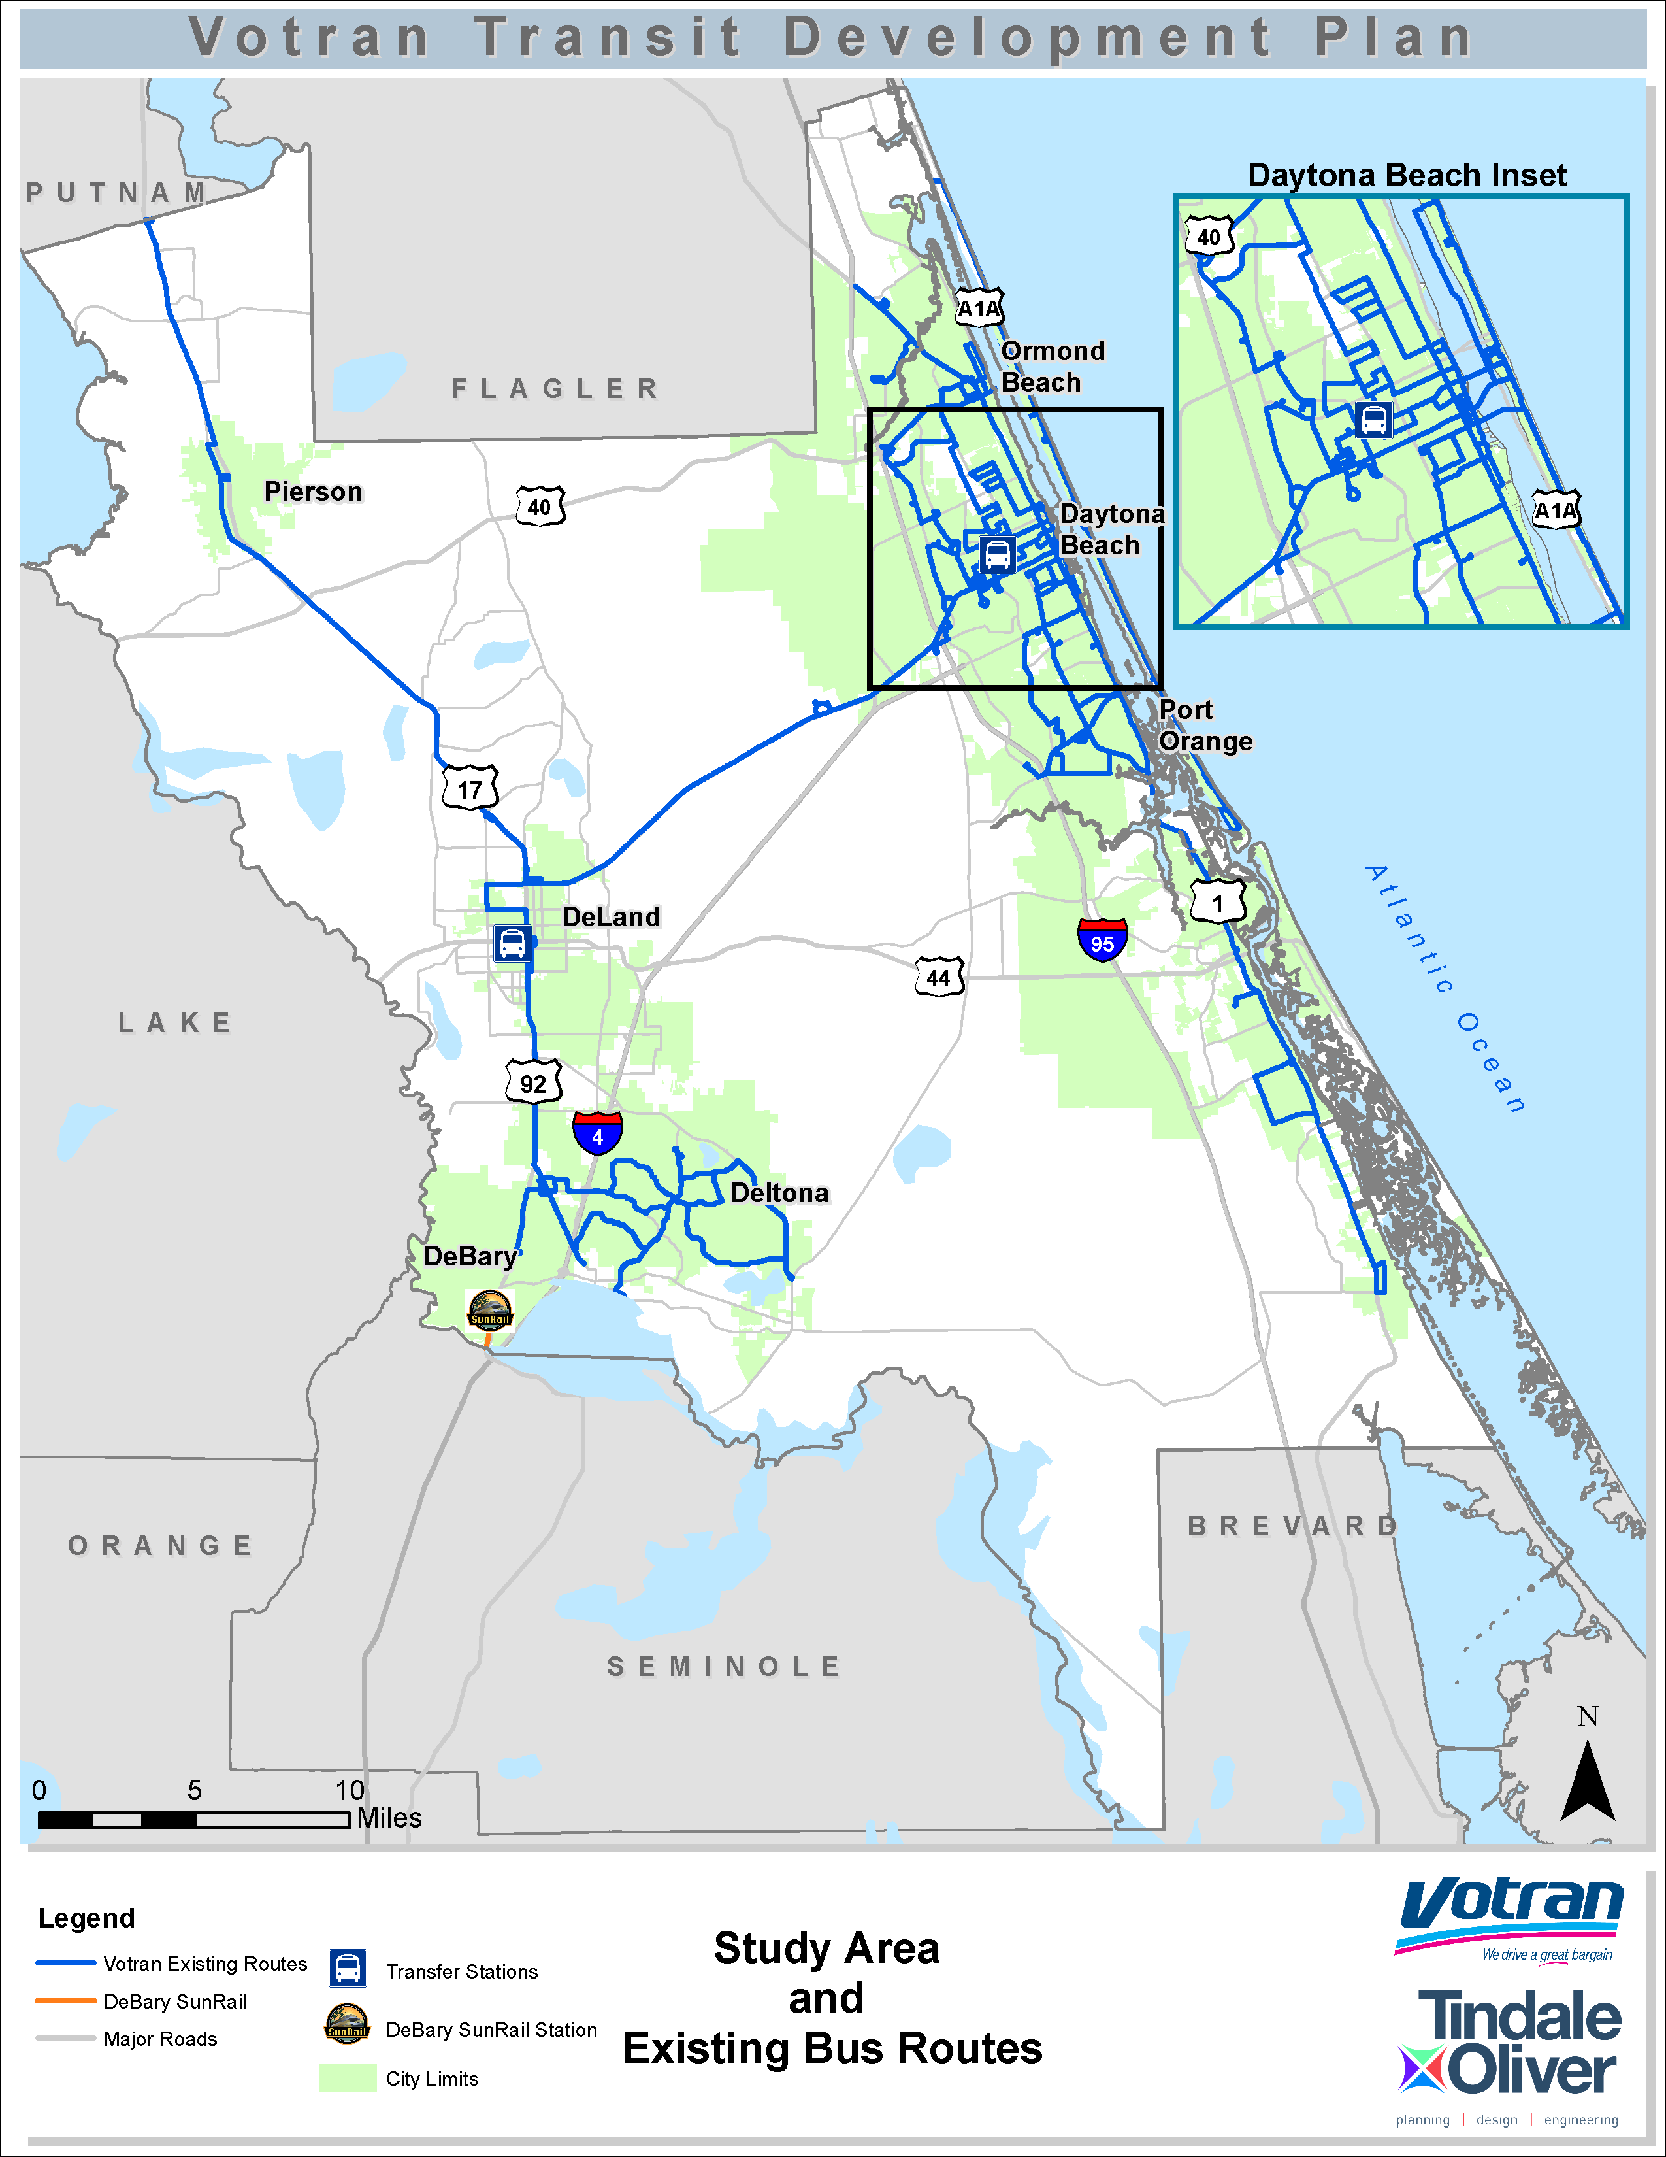

**2016 Transit Development Plan Analysis of the Votran Market**

A traditional transit market refers to population segments that historically have had a higher propensity to use transit and are dependent on public transit for their transportation needs. Traditional transit users include older adults, youth, and households that are low-income and/or have no vehicles.

A Transit Orientation Index (TOI) assists in identifying areas of the county where a traditional transit market exists. To create the Transit Orientation Index for this analysis, five-year demographic data estimates from the 2010–2014 Five-Year ACS estimates were compiled at the census tract level (the most detailed level of data available from ACS) and categorized according to each tract’s relative ability to support transit based on the prevalence of specific demographic characteristics. Five population and demographic characteristics that are traditionally associated with the propensity to use transit were used to develop the Transit Orientation Index:

• Population density (persons per square mile)

• Proportion of the population age 60 and over (older adults)

• Proportion of the population under age 15 (youth)

• Proportion of the population below the poverty level ($25,000 for a family of 4)

• Proportion of households with no vehicles (zero-vehicle households)

Using data for these characteristics and developing a composite ranking for each census tract, each area was ranked as “Very High,” “High,” “Medium,” “Low,” or “Very Low” in their respective levels of transit orientation.

Map below illustrates the Transit Orientation Index prepared for Volusia County, reflecting areas with varying traditional market potential. Also shown is the existing transit route network to show how well Votran covers those areas. Based on this analysis, Daytona Beach and areas surrounding DeLand and DeBary have the highest transit orientation. The existing bus routes align fairly well with the highest transit orientation areas, although there are areas of higher transit orientation north of DeLand and DeBary that are on the periphery of or currently not directly served by the existing transit network.

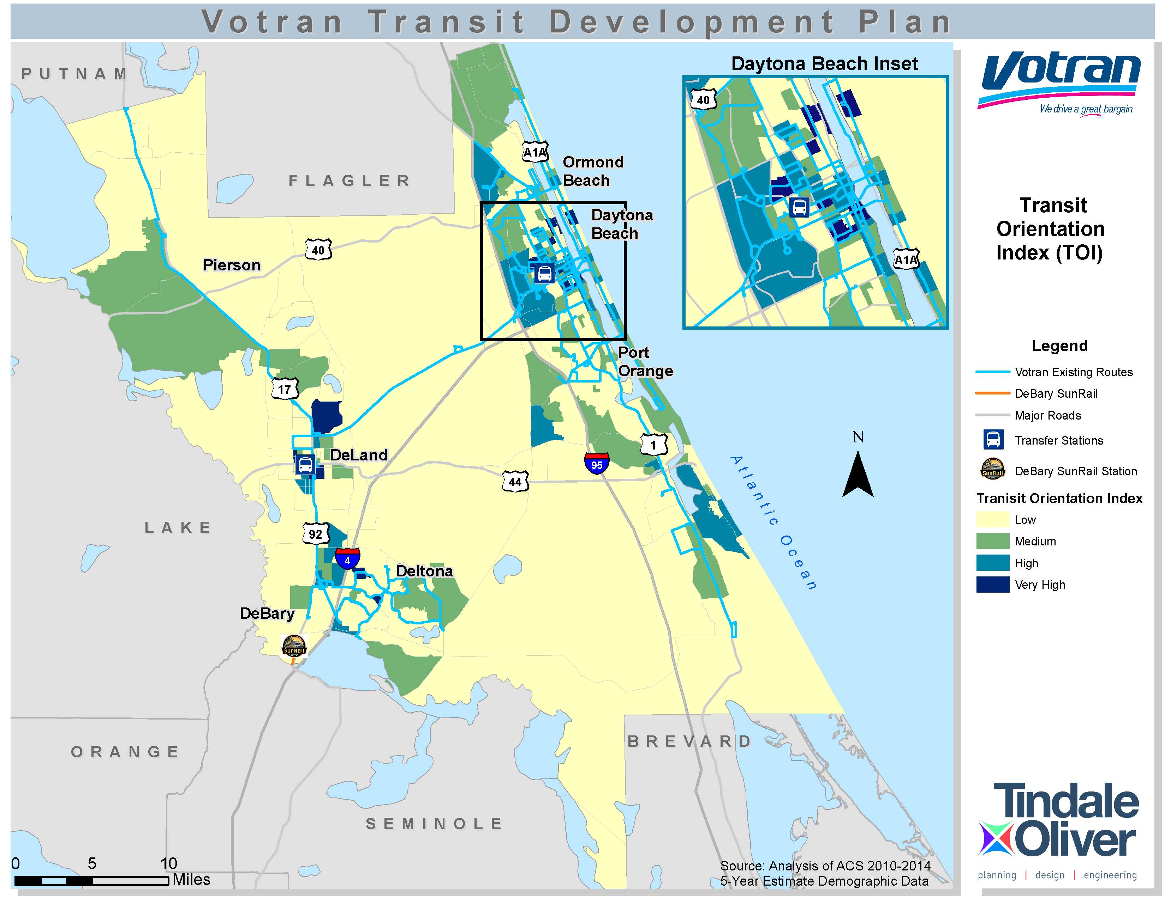

**Languages**

The language spoken in the home was a subject of the 2016 TDP onboard survey. Respondents primarily speak English in the home. The number of respondents that indicated they spoke Spanish in the home was 4%, which is similar in proportion to the census data for the Volusia County population.

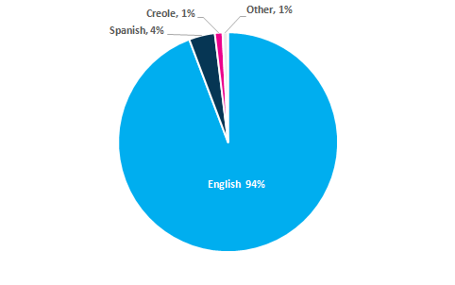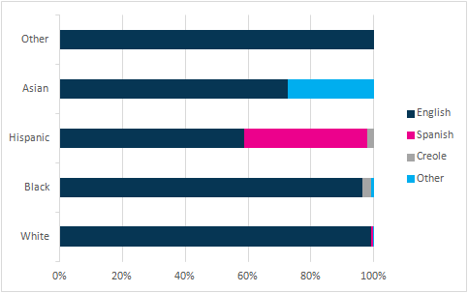



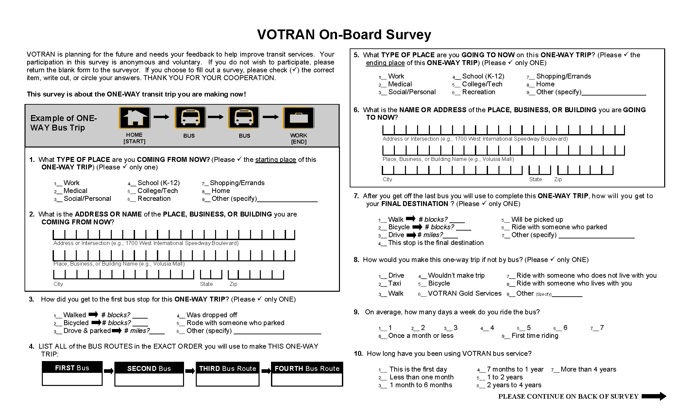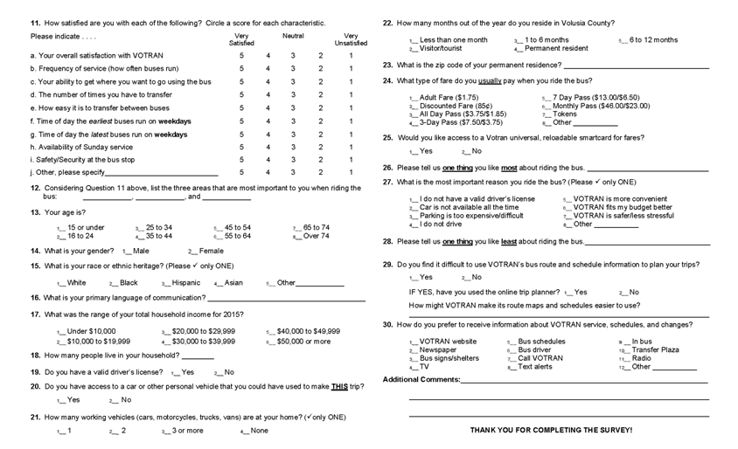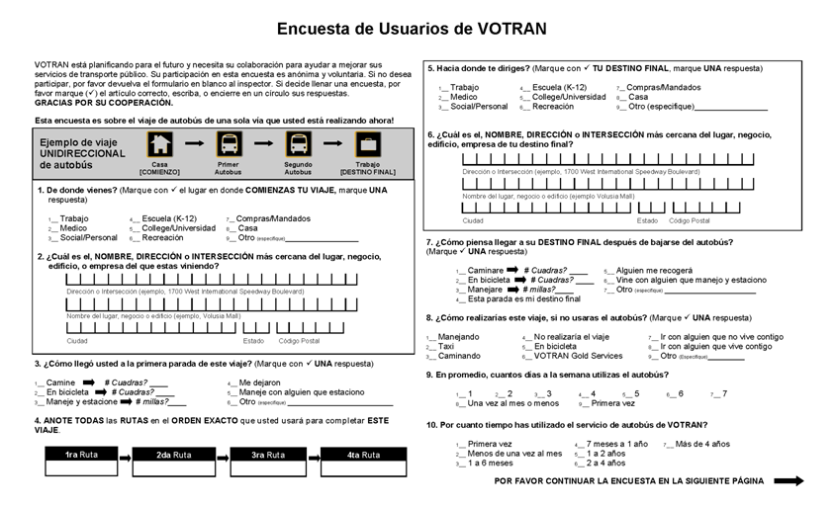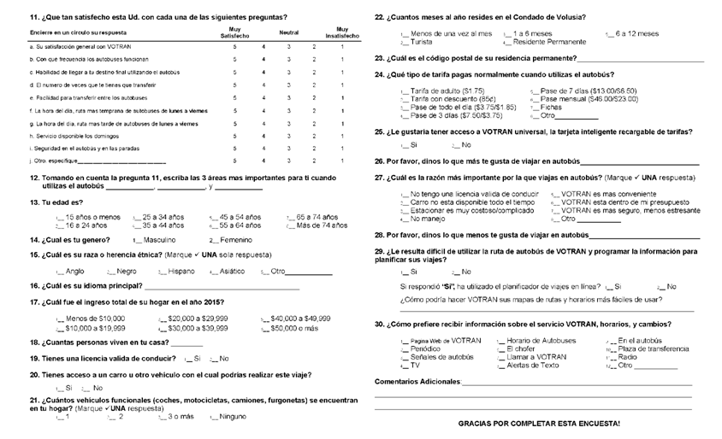

APPENDIX 3 - Public Participation Policy

|  |  |
| --- | --- |
| ***Public Participation Policy*** |  |

Votran operates as a Department of Volusia County Government. Votran utilizes the Volusia County Transportation Planning Organization (TPO) Public Involvement Plan (PIP) process. This policy exceeds the Federal Transit Administration’s Title VI recommendation for public outreach and involvement.

Under the TPO PIP, public comment is obtained from a variety of committees. These committees include, but are not limited to the Citizen’s Advisory Committee (CAC), and the Transportation Disadvantaged Local Coordinating Board. In addition, public notice is provided for all meetings, and public hearings are scheduled for key decision points.

In addition to input through the committee structure, Votran disseminates information and solicits information from the public through “Take Ones” handouts on the buses. Public feedback is requested on issues such as rate increases and service development.

Votran is committed to providing the public the opportunity to comment on changes to service to ensure that the public remains informed of Votran activities and has ample opportunity to provide input, we engage in a variety of activities designed to foster participation. These changes include, but are not limited to Service Reduction, Service Expansion, Service Modification, and Rate Changes. The public comment process is utilized when a modification to the system results in a 10% change in system revenue service, or a 10% change to a specific route, or for any changes to the fare structure. However, because of its commitment to keep the public informed, Votran may also hold public meetings to inform the public of system changes that may affect less than 10% of reductions in revenue service.

The following methods will also be utilized by Votran in an effort to obtain public comment: meetings and workshops, scheduled public hearings, Transit Development Plan Passenger Surveys, Take Ones, Website and Press Releases. All changes in service are posted in advance. Votran also presents information and uses list services for a variety of community organizations that assist in disseminating information to their members.

Votran is committed to providing information in accessible formats, including oral presentations, information distribution in multiple languages, distribution in urban and rural areas, and providing information in large printed materials.

***Votran’s Mission is to identify and safely meet the transportation needs of Volusia County, through a courteous, reliable, cost-effective, and environmentally sound team commitment.***

|  |  |
| --- | --- |
| ***Reviewed by:*** | ***Votran Executive Team*** |
| ***Date Approved:*** | ***April 16, 2018*** |
| ***Responsible Department:*** | ***General Manager*** |
| ***Approval Signature:*** | ***Rob W. Stephens, General Manager*** |