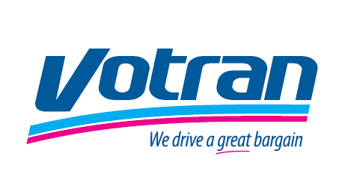

VOTRAN Request for a Reasonable Accommodation

All federally funded public transportation entities are subject to provide reasonable accommodations by making changes to policies, practices, and procedures if needed for an individual with a disability to use the Fixed Route Bus Service, unless providing such accommodations are an undue financial and administrative burden or constitute a fundamental alteration of the program or activity.
Please complete the form below to request a reasonable accommodation and return the form to VOTRAN 950 Big Tree Rd., South Daytona, Fl. 32119.
If the request is based on a medical condition, you may be asked for additional information. You will receive a response to this request within 30 days of receipt by VOTRAN.

Name: _______________________________________________________
Address: _____________________________________________________
Phone: _______________________________________________________

I am requesting the following accommodation: ____________________________________________________________________________________________________________________________________________________________________________________________________________________________________________________
It is necessary for me to have this accommodation for the following reason(s):
_____________________________________________________________
______________________________________________________________________________________________________________________________________________________________________________________________________

________________________________ _____________________
Signature Date

